Accreditation Summary – Bachelor of Early Childhood Education.
National summary statement about the accreditation process
The accreditation process involves a rigorous assessment of an initial teacher education (ITE) program against a set of nationally agreed standards. Accreditation standards and procedures are designed to ensure that all graduates of ITE meet the Australian Professional Standards for Teachers at the Graduate career stage. This ensures the program is of high quality and prepares pre-service teachers for the teaching profession. The process also includes an assessment of a provider’s quality assurance and continuous improvement mechanisms, as well as ensuring that the provider has a nationally endorsed teaching performance assessment which all graduates must successfully complete.

More information on the accreditation process may be found at: https://www.aitsl.edu.au/deliver-ite-programs/standards-and-procedures.

Jurisdiction | Northern Territory
Provider | Charles Darwin University
Program title | Bachelor of Early Childhood Teaching
Program type | Undergraduate
Program duration in equivalent full-time student load (EFTSL) | 4 years (undergraduate)
Minimum program duration | 4 years (undergraduate)
Stage of schooling | Early Childhood  Primary
Mode(s) of delivery | Mixed
Campus location(s) | Casuarina
Approval date of current accreditation | January 2020
Accreditation outcome* | 5 years
Accreditation expiry date (optional) | December 2024
Quality assurance processes in place | The quality assurance processes in place include: ITE committee receiving regular reports from CDU, submission of annual report to TRBNT Board. This will include data gathered internally such as student feedback and external accreditation processes.
Program description and rationale

The (BEDEC) is an existing course that directly addresses national policy reforms in provision of early childhood education and care services to improve the quality of and access for children to a four-year degree qualified educator. It provides dual sector qualifications for teaching birth to 12-year-old children. The flexibility and versatility of this qualification is an advantage to both the graduate and the employer in the context of fluctuating enrolments of different age cohorts and mobility of staff.

To complete the BEDEC course a preservice teacher must complete 31 units. This comprises 2 common units, 28 core units and one elective unit.

Core units in the BEDEC provide three options for primary specialisation in addition to the early childhood specialisation. Preservice teachers may nominate English, Mathematics or Science and Technology as their specialisation and undertake the associated professional experience in their third placement (EPE210).

This table provides an overview of the structure and sequence of professional experience undertaken in BEDEC.
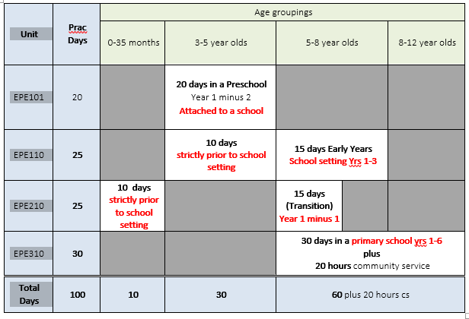
The Teacher Registration Board of the Northern Territory accepted the recommendation of the panel at its meeting on Thursday 5 December 2019.

A link to the course: https://www.cdu.edu.au/study/bachelor-education-early-childhood-teaching-birth-12-years-wedec1-2020

* Note any conditions for accreditation here, if applicable.

